**Name :: himanshu kumar**

**USN :: 1nt21is063**

**Sec :: A**

Q)Implement a circular queue using linked list.

Aim:

To Implement circular queue using linked list.

Algorithm:

Enqueue:

Create a struct node type node.

Insert the given data in the new node data section and NULL in address section.

If Queue is empty then initialize front and rear from new node.

Queue is not empty then initialize rear next and rear from new node.

New node next initialize from front

Dequeue:

Check if queue is empty or not.

If queue is empty then dequeue is not possible.

Else Initialize temp from front.

If front is equal to the rear then initialize front and rear from null.

data of temp and free temp memory.

If there is more than one node in Queue then make front next to front then initialize rear next from front.

Print temp and free temp.

Print:

if there is some data in the queue or not.

If the queue is empty print “No data in the queue.”

Else define a node pointer and initialize it with front.

Print data of node pointer until the next of node pointer becomes NULL.

Code:

#include<stdio.h>

#include<stdlib.h>

struct node

{

int data;

struct node *next;

};

struct node *f = NULL;

struct node *r = NULL;

void enqueue (int d) //Insert elements in Queue

{

struct node *n;

n = (struct node *) malloc (sizeof (struct node));

n->data = d;

n->next = NULL;

if ((r == NULL) && (f == NULL))

{

f = r = n;

r->next = f;

}

else

{

r->next = n;

r = n;

n->next = f;

}

}

void dequeue () // Delete an element from Queue

{

struct node *t;

t = f;

if ((f == NULL) && (r == NULL))

printf ("\nQueue is Empty");

else if (f == r)

{

f = r = NULL;

free (t);

}

else

{

f = f->next;

r->next = f;

free (t);

}

}

void display ()

{ // Print the elements of Queue

struct node *t;

t = f;

if ((f == NULL) && (r == NULL))

printf ("\nQueue is Empty");

else

{

do

{

printf (" %d", t->data);

t = t->next;

}

while (t != f);

}

}

int main ()

{

enqueue (34);

enqueue (22);

enqueue (75);

enqueue (99);

enqueue (27);

printf ("Circular Queue: ");

display ();

printf ("\n");

dequeue ();

printf ("Circular Queue After dequeue: ");

display ();

return 0;

}

Output:

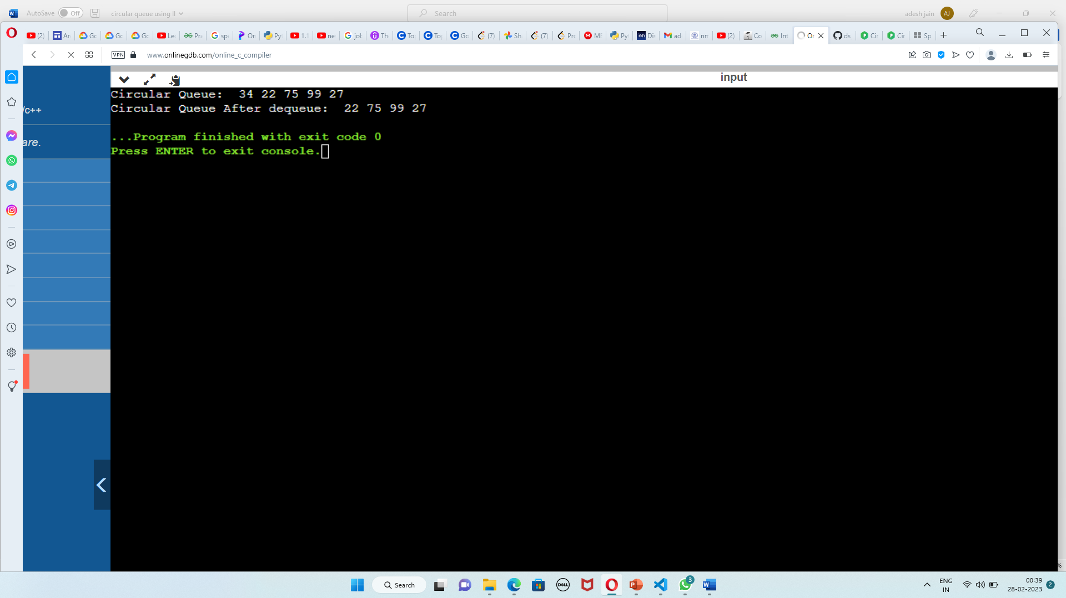

Link: <https://github.com/himanshu120299/Lab-assignment.git>